# Automatic obstacle avoidance vehicle

## ****Infrared obstacle avoidance sensor:** Its principle is the same as the tracking sensor, but it is an analog signal sensor, and the received value is 0~1024.**

The probe of the sensor is an infrared pair tube, one emitting infrared and the other receiving. Within a certain distance, when the sensor is aimed at a white object (bright object), the emitted infrared ray will be sent back and received by the receiving tube. The black object will absorb light, so when the transmitting tube reaches the black object, the infrared ray will be absorbed, and the receiving tube will not receive the infrared ray.

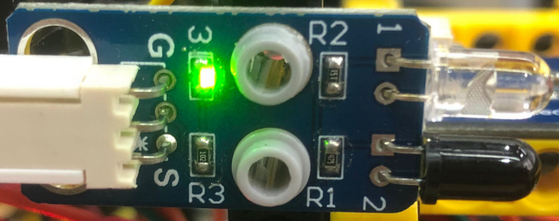

## Install the automatic obstacle avoidance vehicle

Use the structure of the previous lesson without disassembly.

|  |  |
| --- | --- |
| SSJY2-01 套件 蹦蹦 赛车形态_空白视图 2_36 | SSJY2-01 套件 蹦蹦 赛车形态_空白视图 2_37 |
| SSJY2-01 套件 蹦蹦 赛车形态_空白视图 2_38 | SSJY2-01 套件 蹦蹦 赛车形态_空白视图 2_39 |
| SSJY2-01 套件 蹦蹦 赛车形态_空白视图 2_40 | SSJY2-01 套件 蹦蹦 赛车形态_空白视图 2_41 |
|  | |

## Read the value of obstacle avoidance sensor

Note: The principle of infrared obstacle avoidance sensor is to transmit infrared rays and then receive the reflected infrared rays. The sunlight has strong infrared rays, so the value of the sensor will be greatly affected when it is outdoors in the daytime.

1. **Program block**

Read the analog value of the pin, usually connected to the analog sensor. The analog input pin of Arduino UNO main board is only A0~A5.

1. **Example program**

|  |
| --- |
|  |

1. **Experiment phenomenon**

The serial port monitor area of SnailBlock prints the value of infrared obstacle avoidance sensor.

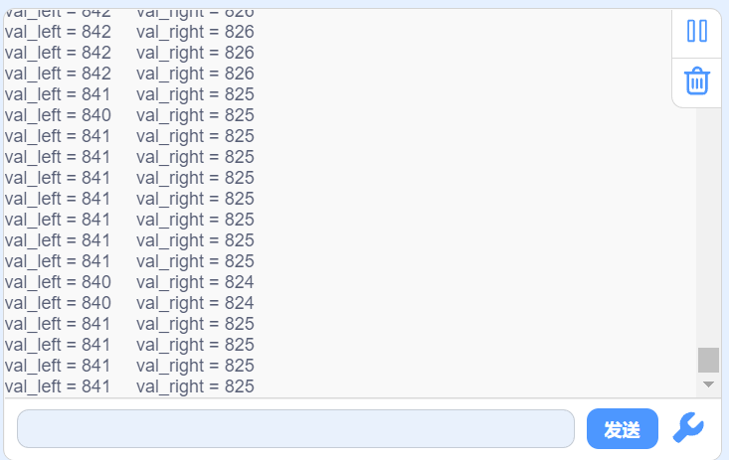

### Proximity alarm

When someone approaches a big truck, the big truck will alarm to remind "The truck is dangerous. Keep away".

1. **Example program**

|  |
| --- |
|  |

1. **Experiment phenomenon**

When the hand approaches the infrared obstacle avoidance sensor, the buzzer will give an alarm.

### Automatic obstacle avoidance vehicle

Let's upload the program in Section 2.1 and record the value measured by the infrared obstacle avoidance sensor when the obstacle is 20cm away from the front wheel of the vehicle. The value I measured is about 780. We take it as the value of obstacles in front.

1. **Program idea**

|  |  |  |
| --- | --- | --- |
| Measured value on left | Measured value on right | Direction |
| >780 | >780 | Forward |
| >780 | <780 | Turn left |
| <780 | >780 | Turn right |
| <780 | <780 | Step back and turn left |

1. **Example program**

|  |
| --- |
|  |

1. **Experiment phenomenon**

The vehicle can avoid obstacles automatically, but it can only avoid obstacles in a simple environment. If you feel that the obstacle avoidance distance is not appropriate, or the turning angle is not enough after encountering obstacles, you can adjust it according to the actual situation.